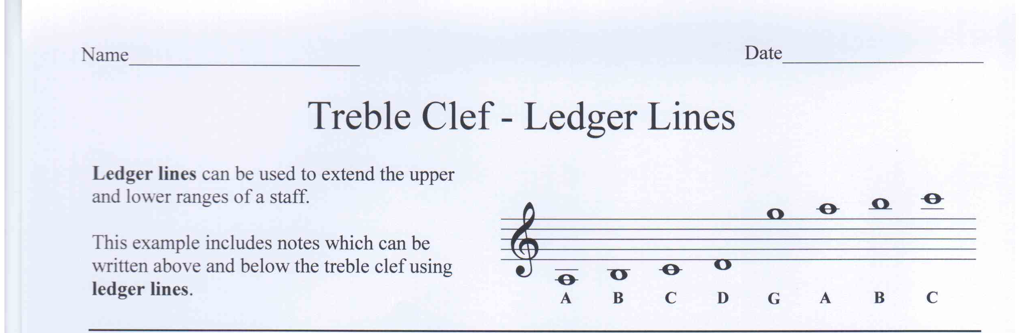

Write the letter name of each note.
A
C
D
G
D
E
B
E

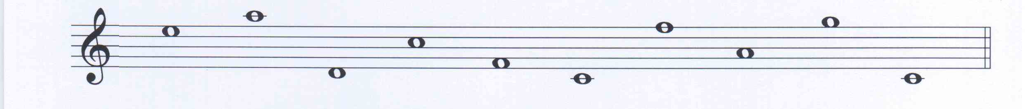
E
A
D
C
D
C
F
G
G
C

What is a ledger line?

Used to extend the upper and lower ranges of a staff.

What is another name for the treble clef?

G Clef

